Thank You Video PSA – Script and Filming Guidelines
For this month’s project we’ll be working together to create a PSA thanking drivers for making safe driving decisions. The video will feature a different person for each line of the video (similar to the young driver video we did last June).
To participate: Sign up for a line by opening the sign-up document in Teams and putting your name next to the line you’re going to film. (If you have any trouble accessing the document, let me know and I can sign you up.) Partner with someone who is recognizable for the good they do in your community. It could be an emergency responder, a civic leader, a teacher, a nurse, a community advocate or anyone else you think would fit.
WTSC Director Shelly Baldwin will be doing the first and last lines of the script.
Line # | Script
1 | Hello, I’m Shelly Baldwin, and to so many drivers in Washington, I want to say thank you.
2 | Thank you for setting aside any distractions before driving.
3 | Thank you for watching out for people walking and riding bikes.
4 | Thank you for respecting the speed limit.
5 | Thank you for planning ahead, so you never drive impaired.
6 | Thank you for being a great example to our kids and young drivers.
7 | Thank you giving yourself extra time for changing road conditions.
8 | Thank you for slowing down and leaving extra room for the folks working on our roads.
9 | Thank you for taking the time to clear your windshield on icy days.
10 | Thank you for being a designated driver and getting your friends safely home.
11 | Thank you for your kindness and patience with other drivers.
12 | Your safe driving decisions make this holiday season safer for all of us, so again, thank you.
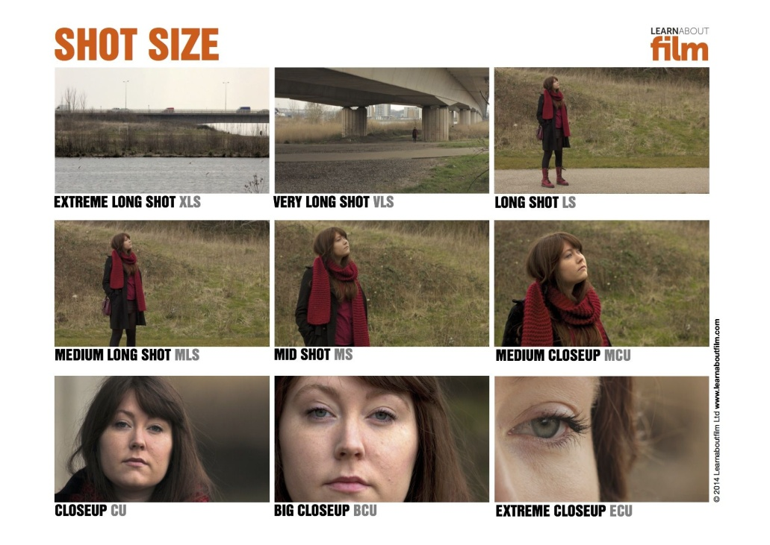
Filming Guidelines:
Format: Since we’ll all be contributing to one video, it’s important that we capture video in the same format; shoot the video holding your phone horizontally so the result is wide screen – not tall and skinny.
Framing: Have your subject fill the frame somewhere around the mid shot to medium closeup as seen in the image to the right.
Audio: Choose a location with minimal background noises and, if you’re shooting outside, avoid windy days. Use an external mic if you have one.
Timing: Start recording a few seconds before your subject says their line and allow a few more seconds before stopping the recording. That’ll help when it comes time for editing.
Submit: Send your videos to ddahl@wtscwa.com by November 15th. Include the name of your talent, their title and the city they live in.

