Video Production Refresher
Last fall we had Kelley Guenther provide us with some training on how to create great video with a smart phone. For anyone looking for a refresher, or if you missed it the first time around, here’s a link to four training videos:
https://www.wtscpartners.com/target-zero/2020/11/30/target-zero-manager-video-training/
The videos require a password: TZMTraining
The same password works for all four videos.
Quick Tips
Along with Kelly’s in-depth training, here are a few quick tips on how to get good results for your video:
Keep It Steady: Stable video instantly increases the perceived quality of a project (unless you’re intentionally going for the shaky Blair Witch Project/Cloverfield look.) Mount your phone on a tripod or other phone mount. If you have to shoot hand-held, use a camera rig (if you have one), use both hands and press your elbows against your torso for stability.
Get Great Audio: Shoot your video in a location with minimal background noise. Turn off fans or other ambient noises if you can. If you have one, plug a mic into your phone; it’ll get better audio than the internal mic.
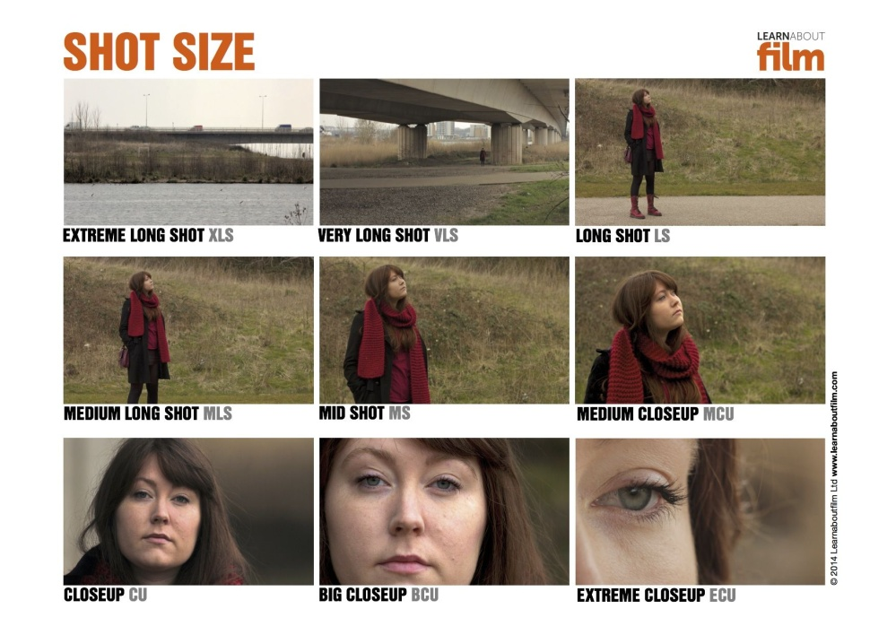
Light It Up: Low light will result in grainy images. Set up in a position that gets plenty of natural light, and use that light to shine on your talent rather than backlighting your talent and creating a silhouette. Use a video light if you have one. Even if a room is bright, using a light helps. Shining a light on your talent helps the viewer focus on what’s important.
Composition: Unless your video is going to be viewed exclusively on mobile devices, shoot horizontally. It’ll work the best on most platforms. On interviews, get close to your subject. I’d recommend a mid shot or medium close up. To the right is an example of shot sizes. For the best image quality, you’re better off moving the camera closer than using the zoom function on your phone.
Location: Chose a setting where the background doesn’t distract viewers from your message. Also, you don’t want a bunch of activity nearby or the potential for disruptions; things that could disrupt you or your talent from a train of thought.

