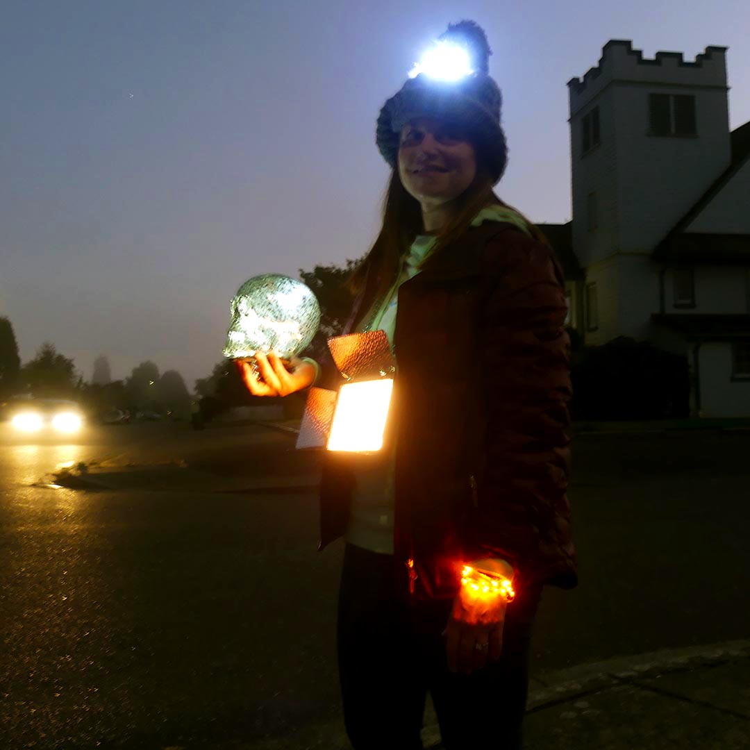
Sample Pedestrian Safety Photo and Message
Washington’s Brightest Pedestrian – Featuring Jodi Greene, School Nurse, sporting a dual-flashlight beanie, giant light medallion necklace, light-up bracelet, and glowing skull lantern.

Nearly all of us walk daily. And around 75 percent of us drive sometimes. Whether we’re walking or driving, there are things we can do to help each other out.

When you’re on foot, do what you can to be noticed, and watch for cars. Cross the street where drivers expect you – at crosswalks and intersections. Seventy-two percent of pedestrian fatalities occur at non-intersections.

When you’re driving, slow down and watch for pedestrians, who can be hard to see, especially this time of year when it’s getting dark earlier.

Inevitably, people walking and people driving sometimes share the same space. When those two activities collide, pedestrians have the disadvantage. For the last seven years pedestrian fatalities in Washington have increased, culminating in 104 lives lost last year, 13 of those in the Northwest region of the state. We can change that. You don’t have to dress up like Washington’s brightest pedestrian; but we all can do our part to prevent crashes and save lives.

Together we get there.

Use/modify this sample as you’d like for your region. For my photo I chose a local school nurse because she’s recognizable for many families in the community (and she’s also the wife of a Sergeant at one of our partner agencies – and a good sport.) I used lighted items I had around the house. I’m sure you can get even brighter (especially if you use law enforcement – they love flashlights.)

Local pedestrian fatality data is available from the WTSC Fatalities Dashboard: https://wtsc.wa.gov/research-data/fatalities-dashboard/

