August 2020 TZM PCN Project – Region 11

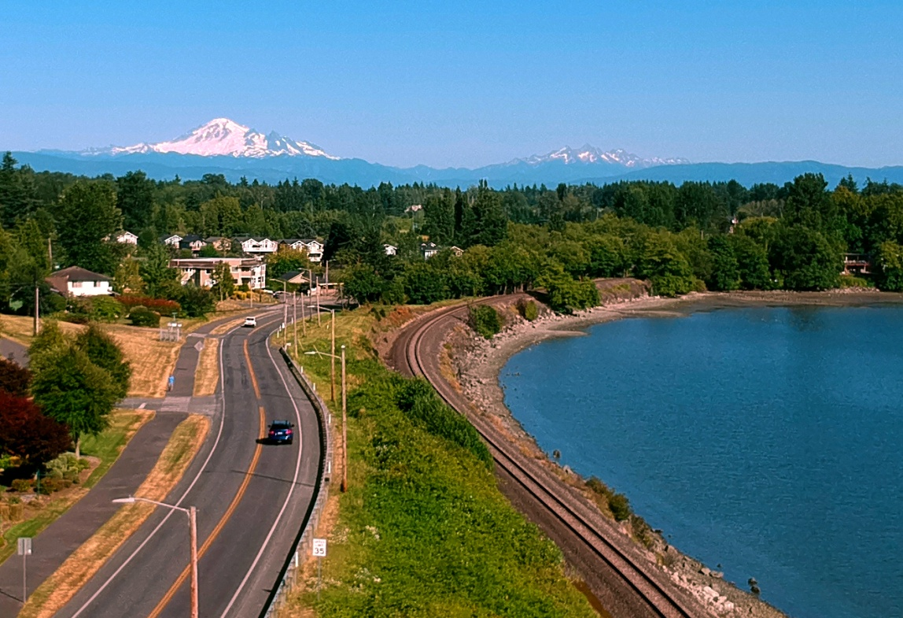
Most of us in the northwest corner of Washington don’t drive impaired; the few that do were responsible for over 50 percent of fatal crashes in our community over the past three years.

It’s going to take all of us to drive that number to zero. And that’s exactly what’s happening. Most Washingtonians (90%), when in a situation to intervene, have taken action to prevent someone from driving impaired.

If you encounter a situation where someone might drive impaired you can:
- Arrange for or provide a ride
- Arrange for the person to stay where they are
- Engage someone else to help, including calling 911 if the person drives

Starting next week, law enforcement in northwest Washington and across the state will be conducting extra patrols to get impaired drivers off our roads. Working together, we can end impaired driving in our communities.

Note:
I chose to use three years of data and group my four counties together. Because of the small data sets the numbers weren’t very helpful unless aggregated. For example, in San Juan County one year they had zero DUI fatalities and two years where 100% of their fatalities involved impairment. But they only had a total of 4 fatalities in 3 years.

